Batch: A1 Roll No.: 16010123012
Experiment No.: AWS 1
Grade: AA / AB / BB / BC / CC / CD /DD

Title: Launching and Managing Virtual Servers using Amazon EC2
Objective: To launch, configure, connect, monitor, and manage a virtual server using Amazon EC2 in AWS Cloud.
Expected Outcome of Experiment:
CO | Outcome
- Understand basic cloud computing concepts
- Launch an EC2 instance
- Configure security groups
- Connect to an EC2 instance using SSH
- Install and configure a web server
- Monitor instance performance
- Manage instance lifecycle states
Books/ Journals/ Websites referred:
ap-south-1.console.aws.amazon.com
Abstract: This experiment focuses on understanding and implementing cloud computing concepts using Amazon EC2 (Elastic Compute Cloud). It involves launching and configuring a virtual server in the AWS environment, setting up security groups to control access, and establishing a secure connection using SSH. The experiment also includes installing and configuring a web server on the EC2 instance to host applications. Additionally, it covers monitoring instance performance using AWS tools and managing different instance lifecycle states such as start, stop, and terminate. Through this practical implementation, users gain hands-on experience in deploying, managing, and maintaining scalable virtual servers in a cloud environment.
Related Theory:
Cloud Computing: Cloud computing provides on-demand delivery of computing resources such as servers, storage, and networking over the internet.
Amazon EC2: Amazon EC2 (Elastic Compute Cloud) is a web service that provides resizable virtual servers in the cloud.
Key Concepts
AMI (Amazon Machine Image): Pre-configured operating system template
Instance Type: Hardware configuration (CPU, RAM)
Key Pair: Secure authentication mechanism
Security Group: Virtual firewall controlling inbound/outbound traffic
EBS Volume: Persistent storage attached to instance
Implementation Details:
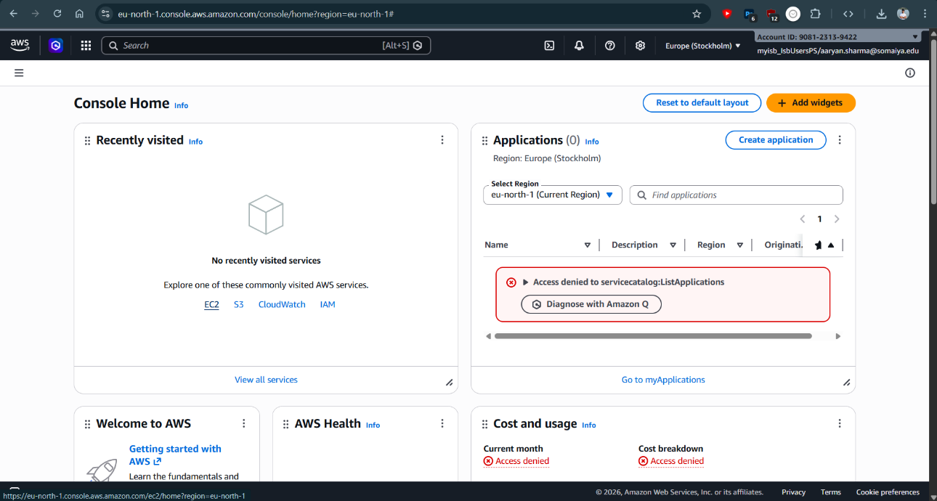
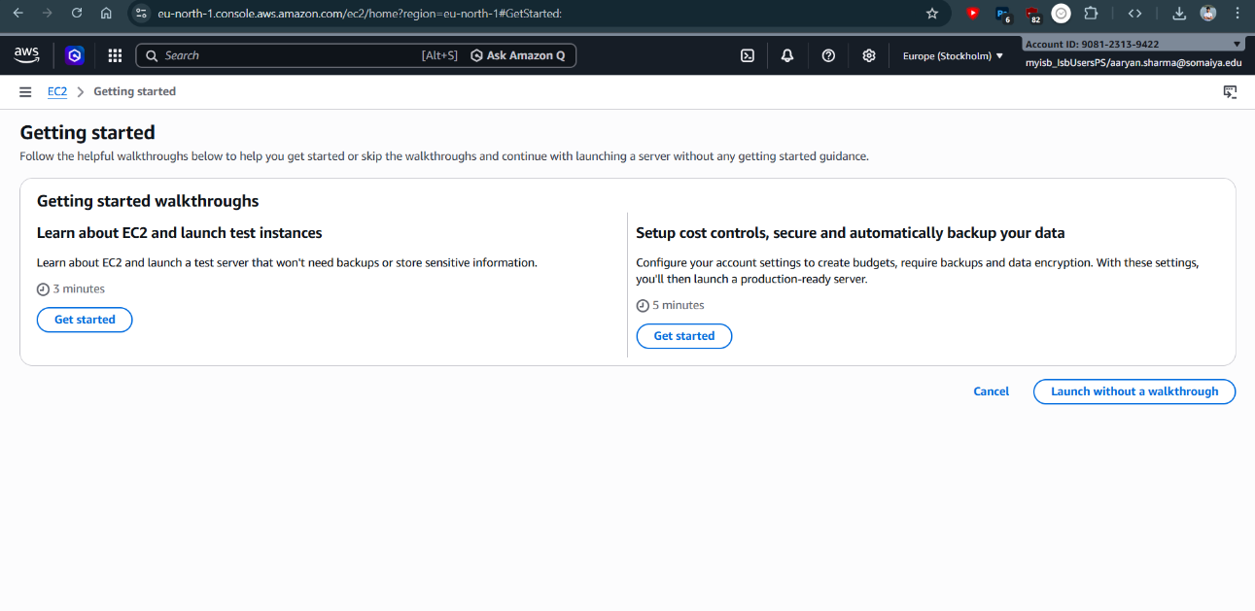
AWS EC2 dashboard showing options to launch a new instance

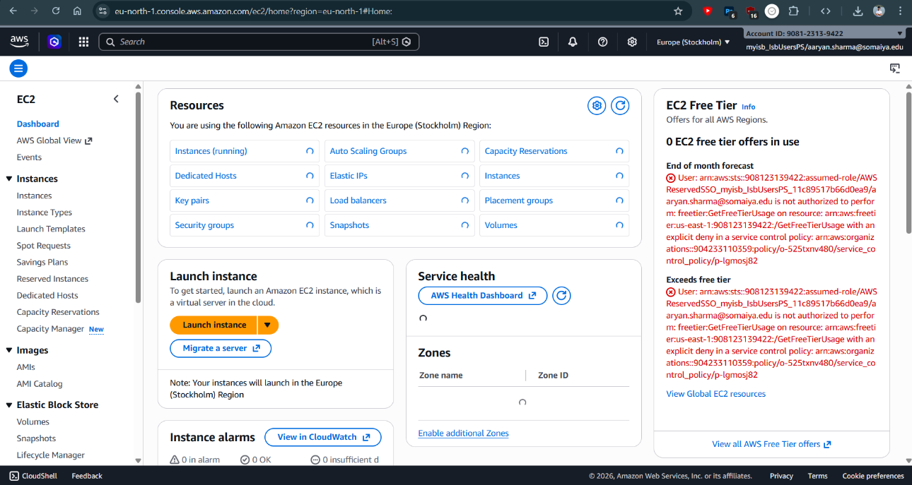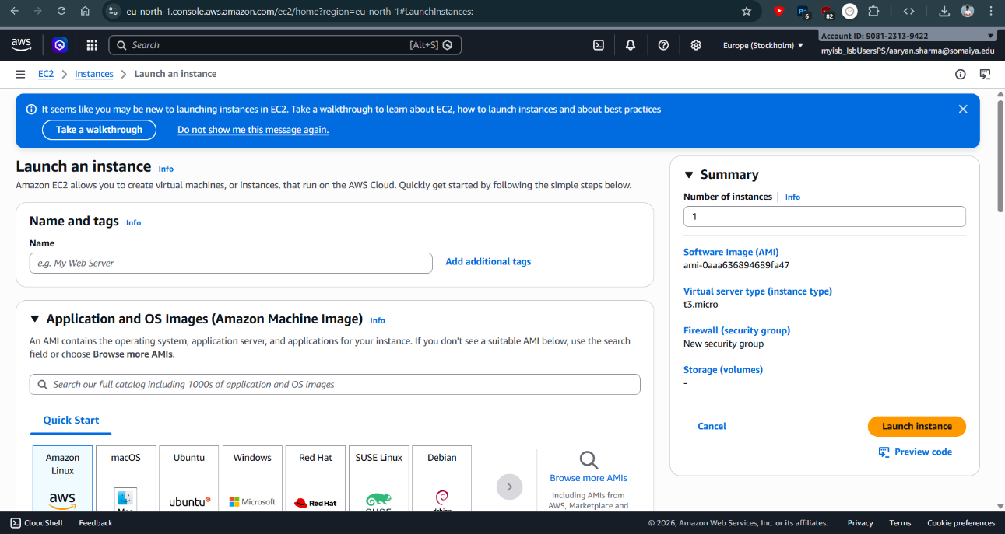
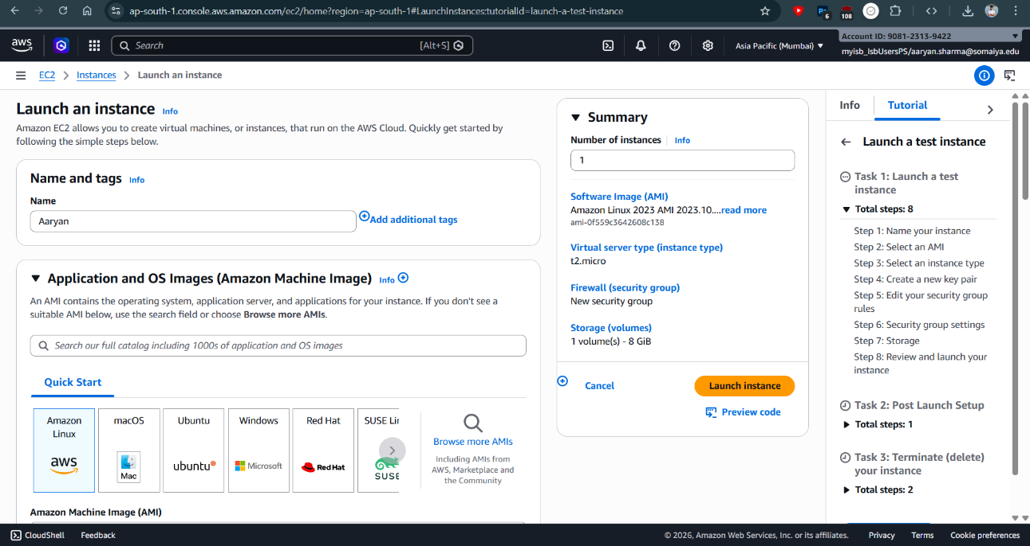
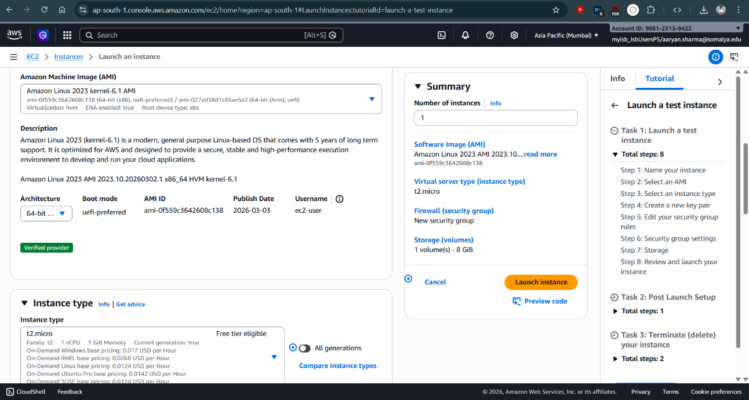
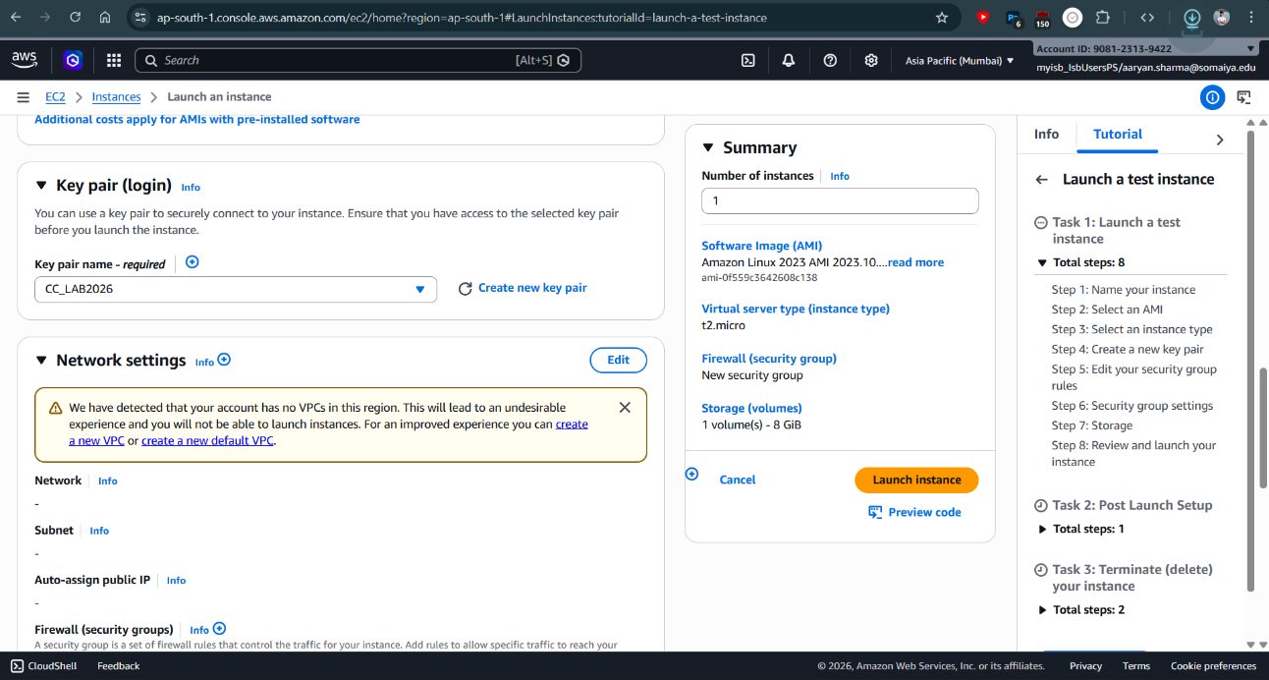
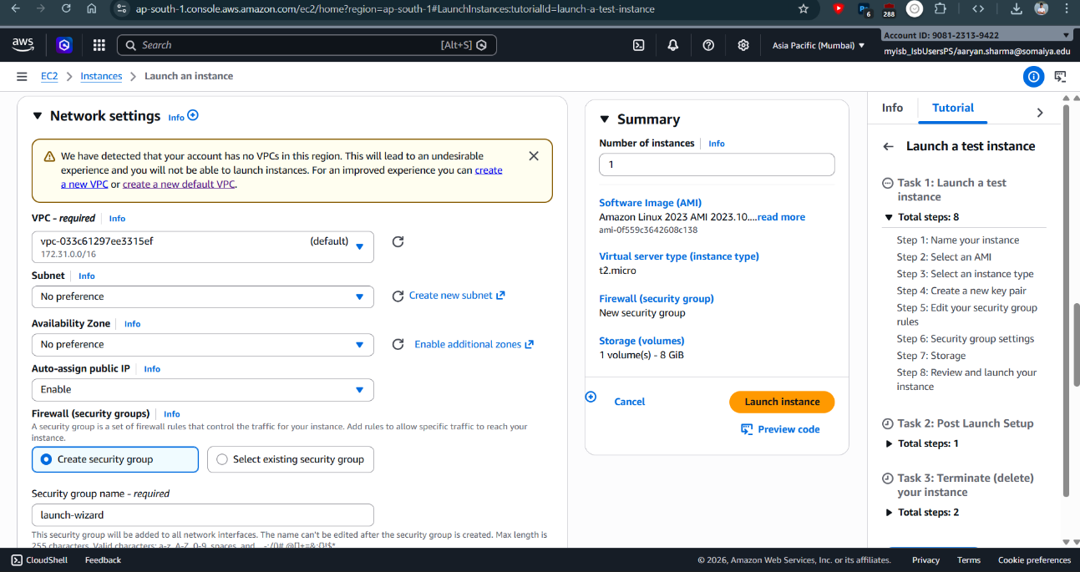
Configuration of EC2 instance including AMI, instance type, and key pair selection

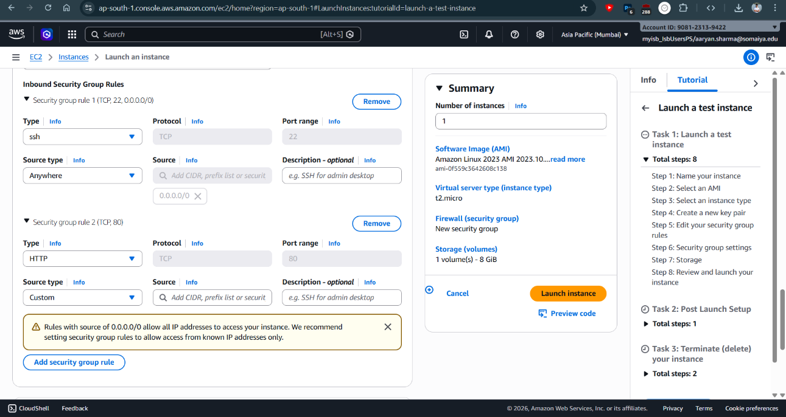
Configuration of security group rules allowing SSH (port 22) and HTTP (port 80) access
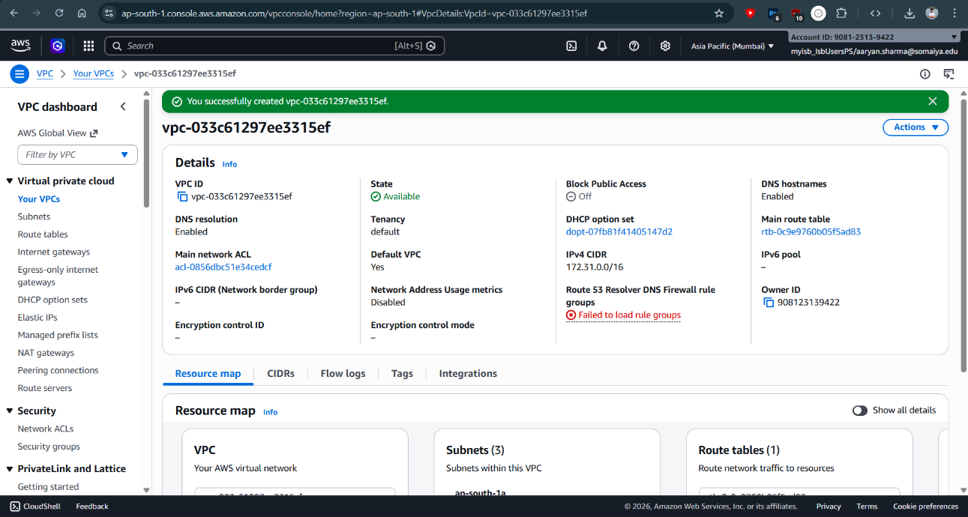
EC2 instance successfully launched and in running state

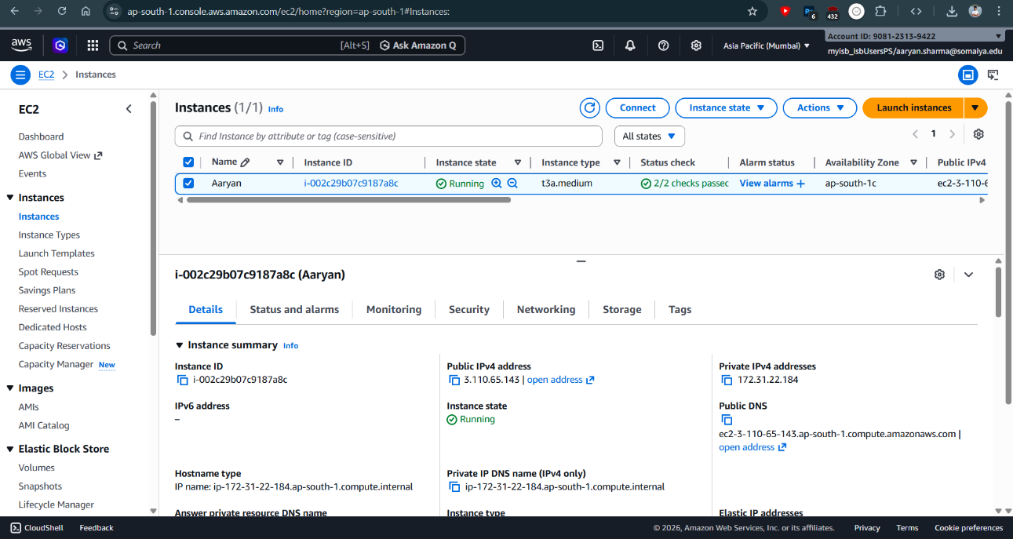
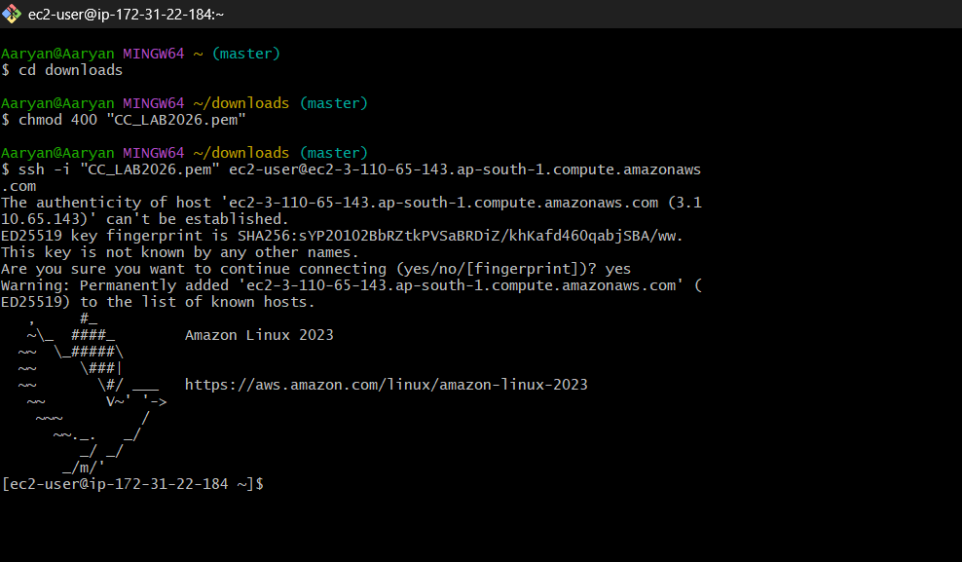
EC2 instance connection setup showing SSH connection details
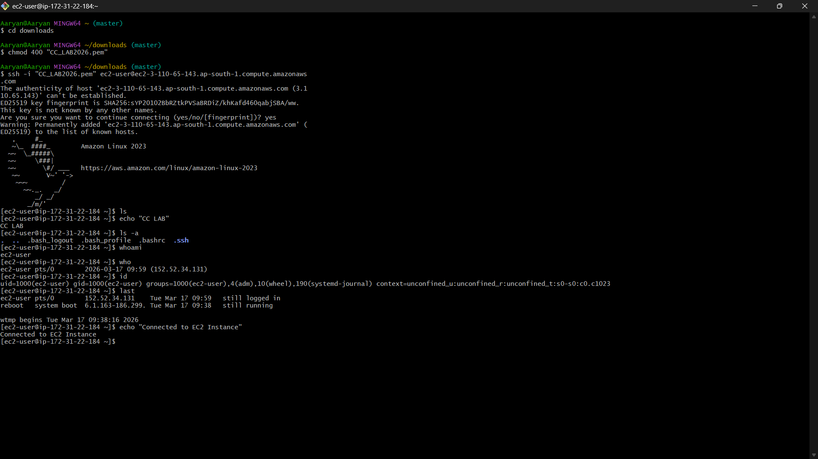
Successful SSH connection to EC2 instance terminal
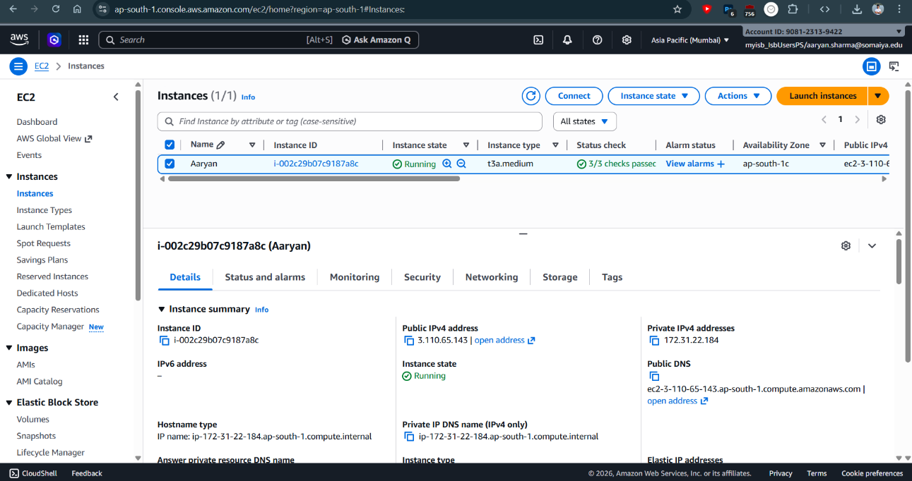
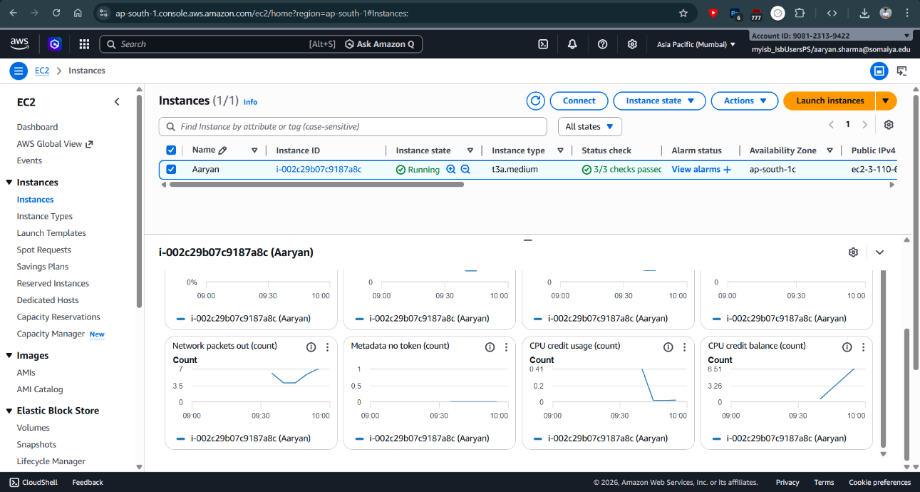
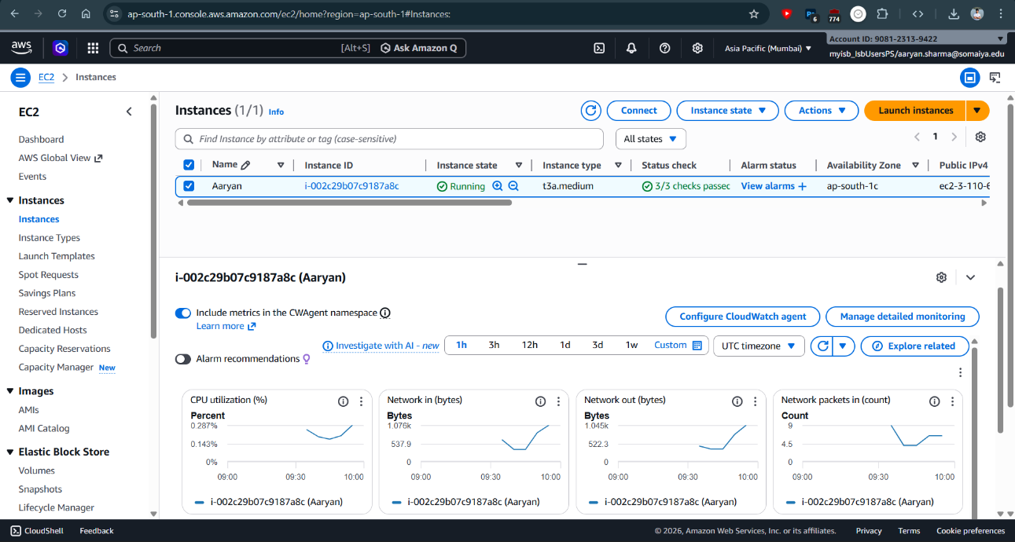
Monitoring EC2 instance performance using AWS console
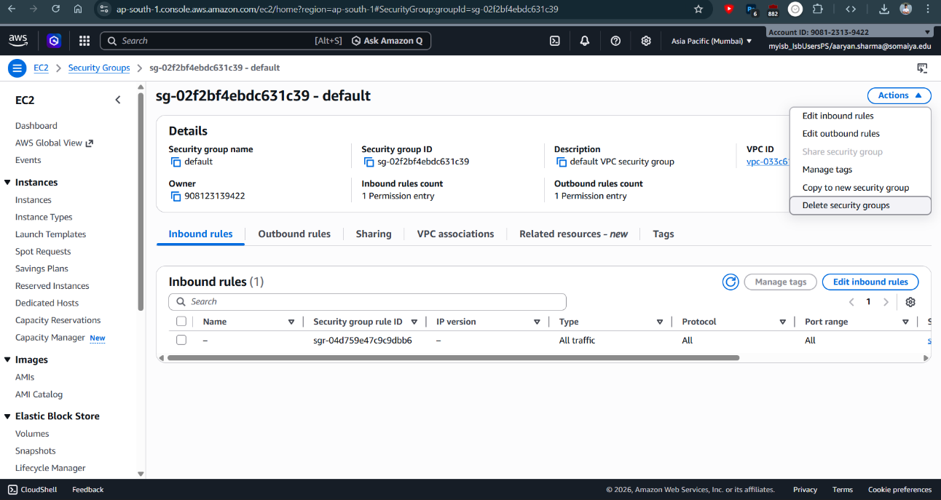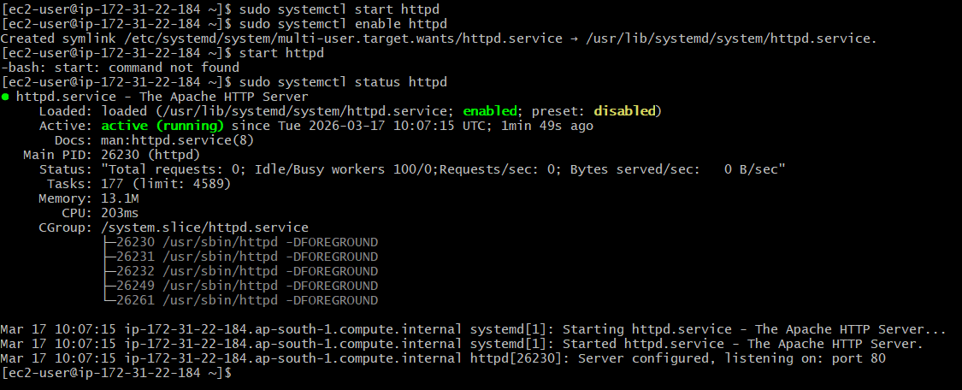
Installation and configuration of Apache web server on EC2 instance

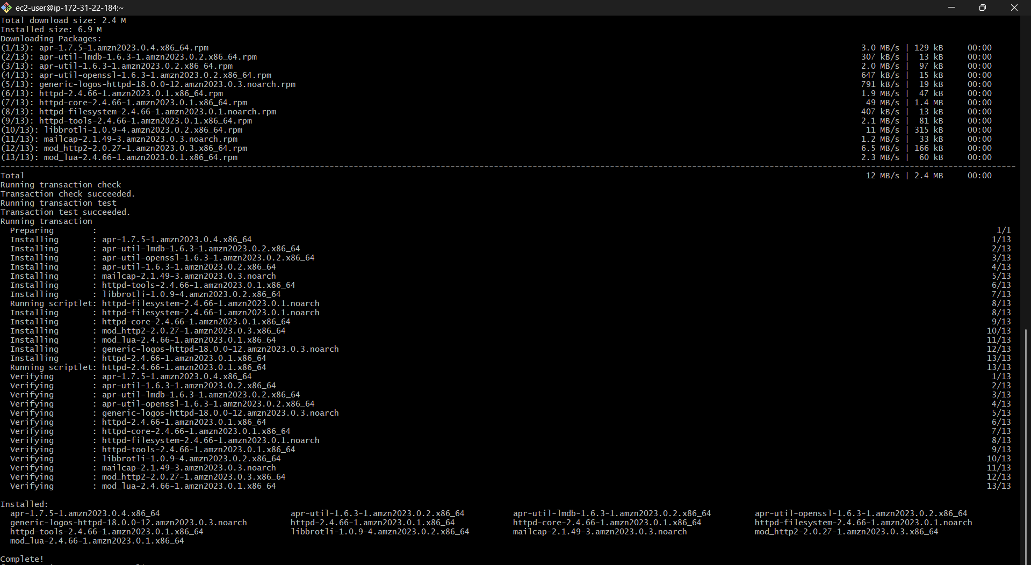
Starting and enabling Apache web server using systemctl commands
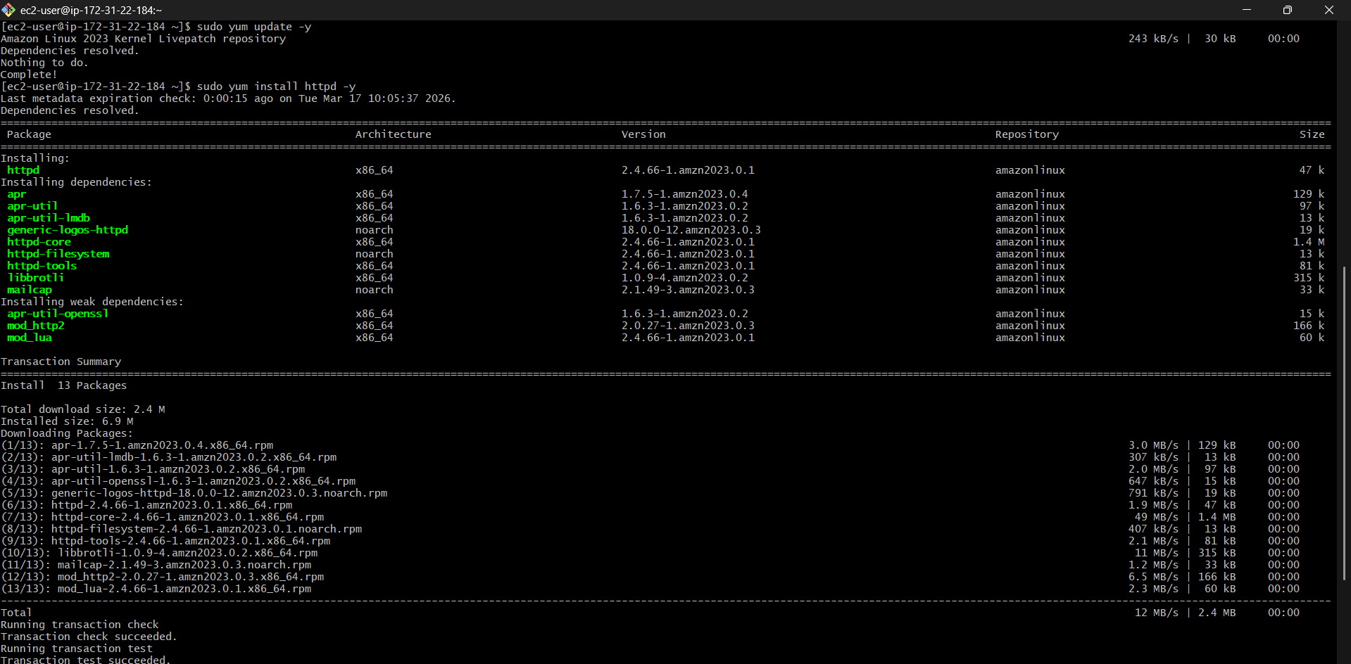
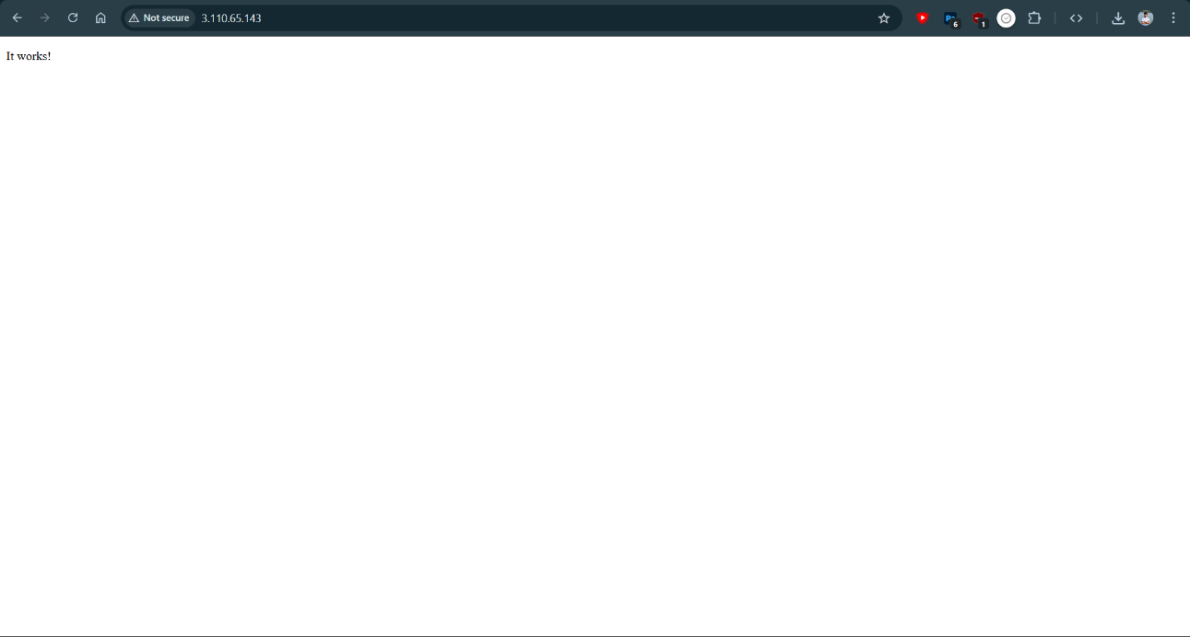
Successful deployment of web server displayed using EC2 public IP address
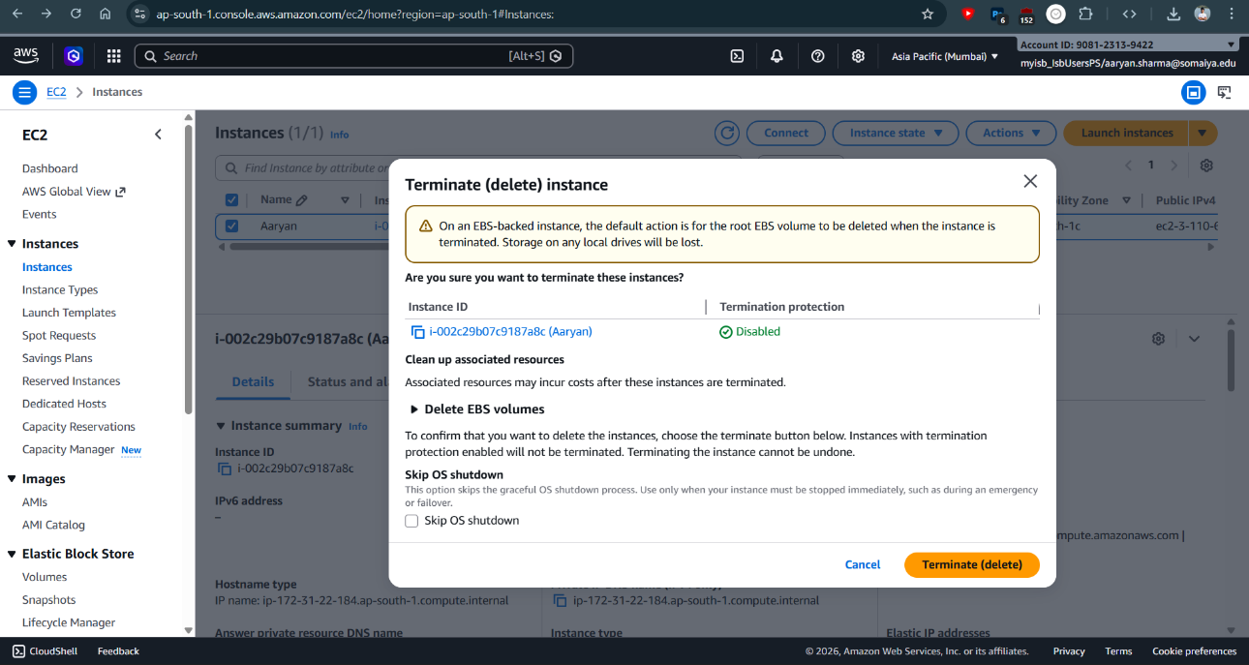
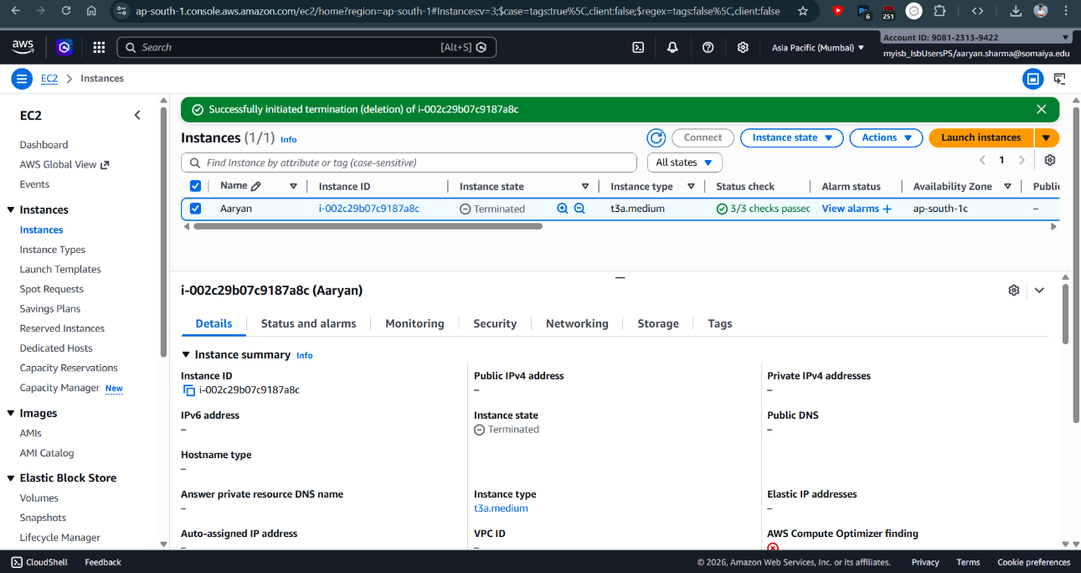
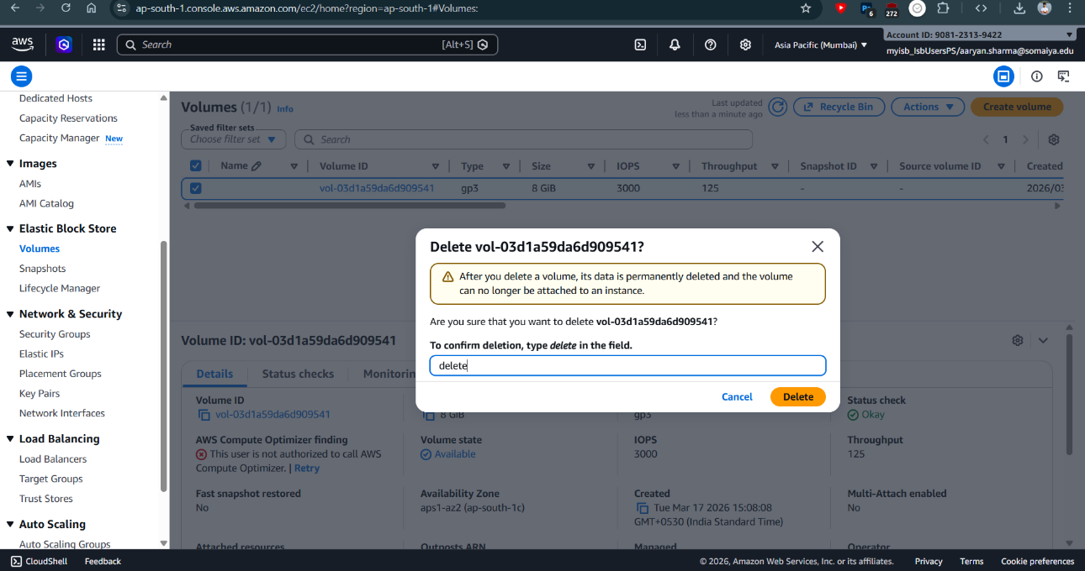
Termination of Instance and the services
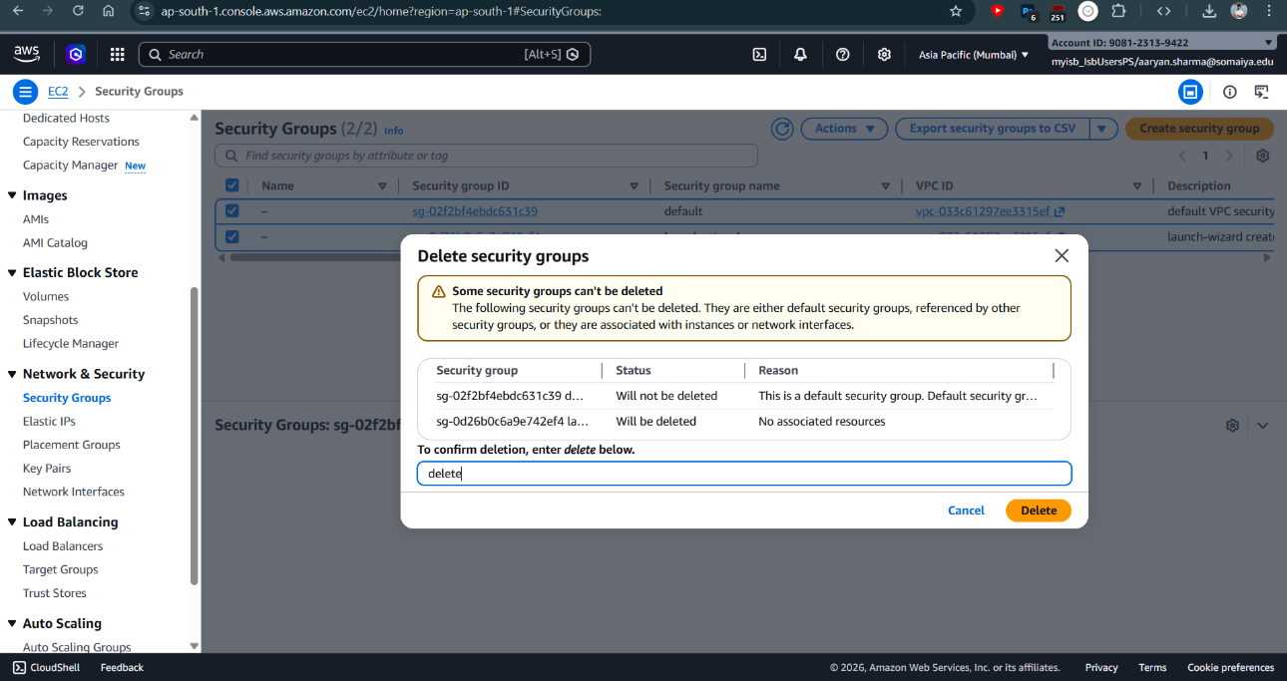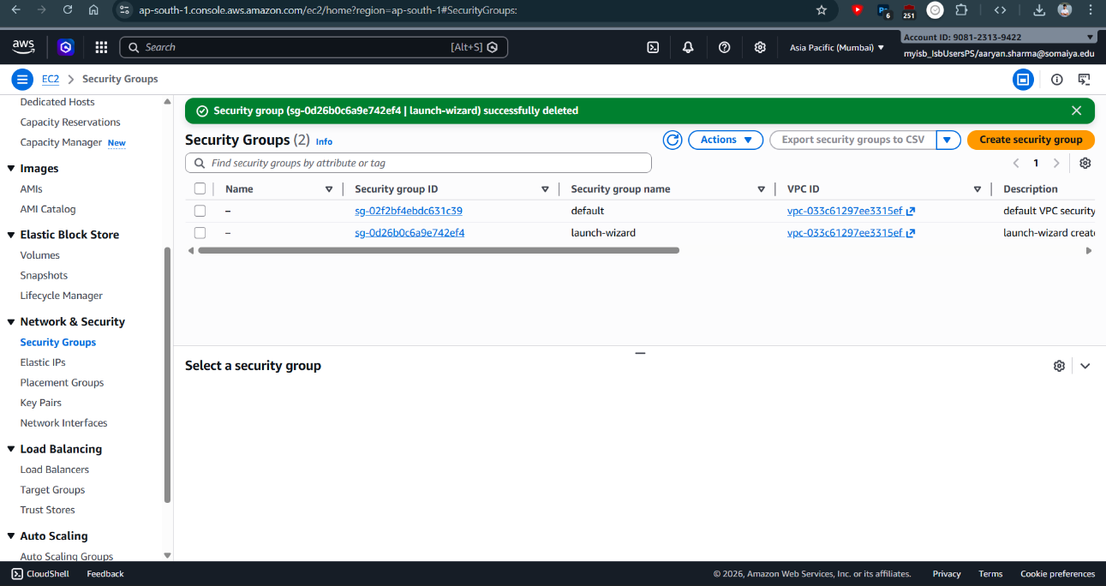
Conclusion:
In this experiment, a virtual server was successfully launched and managed using Amazon EC2 on the AWS cloud platform. The EC2 instance was configured with appropriate parameters such as AMI, instance type, key pair, and security group settings. A secure connection to the instance was established using SSH, and a web server (Apache) was installed and configured on the instance. The application was successfully accessed through the public IP address, demonstrating real-time web hosting on cloud infrastructure. This experiment provided practical understanding of Infrastructure as a Service (IaaS) and demonstrated how cloud platforms enable scalable, flexible, and on-demand computing resources.

